

MODERN EDUCATION SOCIETY’S,

**CUSROW WADIA INSTITUTE OF TECHNOLOGY,**

PUNE - 411001

PROJECT REPORT

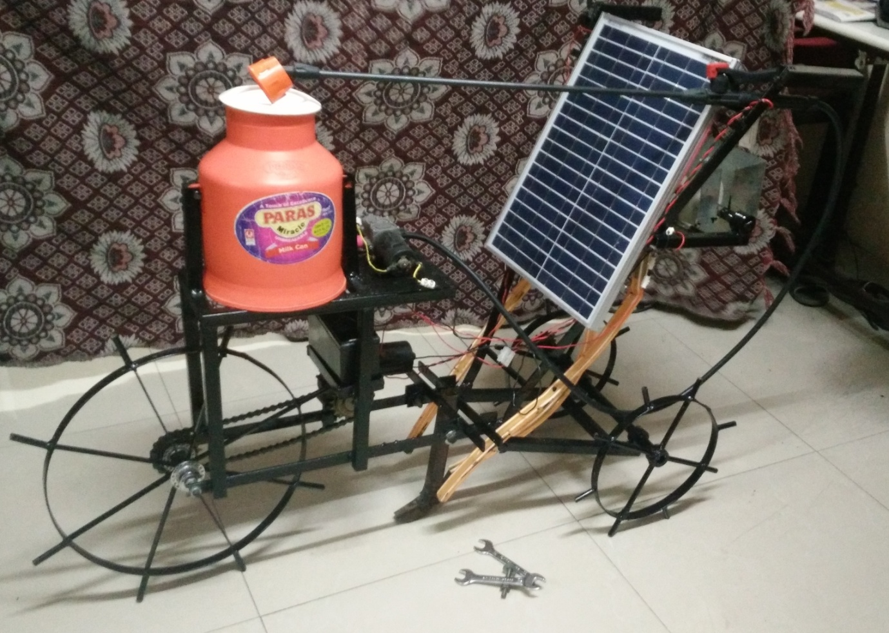

**SOLAR BASED**

**SPRAY PUMP AND SEED SOWING UNIT**

PROJECT SUBMITTED BY:-

1. LAWAND MALOJI. V. - 133036
2. LOLE TUSHAR B. - 133038
3. MOHITE RANJITSINH - 133040
4. PATIL ABHISHEK A. - 133044
5. PAWAR OMKAR A. - 133046

UNDER THE GUIDANCE OF :-

PROF. Ms. MANKAR K.G.



MODERN EDUCATION SOCIETY’S,

**CUSROW WADIA INSTITUTE OF TECHNOLOGY,**

PUNE - 411001.

**CERTIFICATE**

This is to certify that the following students have satisfactorily completed their term work in the subject ***project work*** as detailed above, during the period from Dec-2015 to May-2016.

|  |  |  |
| --- | --- | --- |
| Sr.No. | Name of Student | Enrollment No. |
| 1 | LAWAND MALOJI. V | 133036 |
| 2 | LOLE TUSHAR .B. | 133038 |
| 3 | MOHITE RANJITSINH .N | 133040 |
| 4 | PATIL ABHISHEK .A. | 133044 |
| 5 | PAWAR OMKAR .A. | 133046 |

Project guide H.O.D

(Ms.K.G.MANKAR) (Ms.K.G.MANKAR)

**Prize winning**

**“BEST PROJECT WITH SOCIAL IMPACT”**

**From- “AVISHKAR”** Project exhibition competition.

Zeal collage of engineering, Pune.

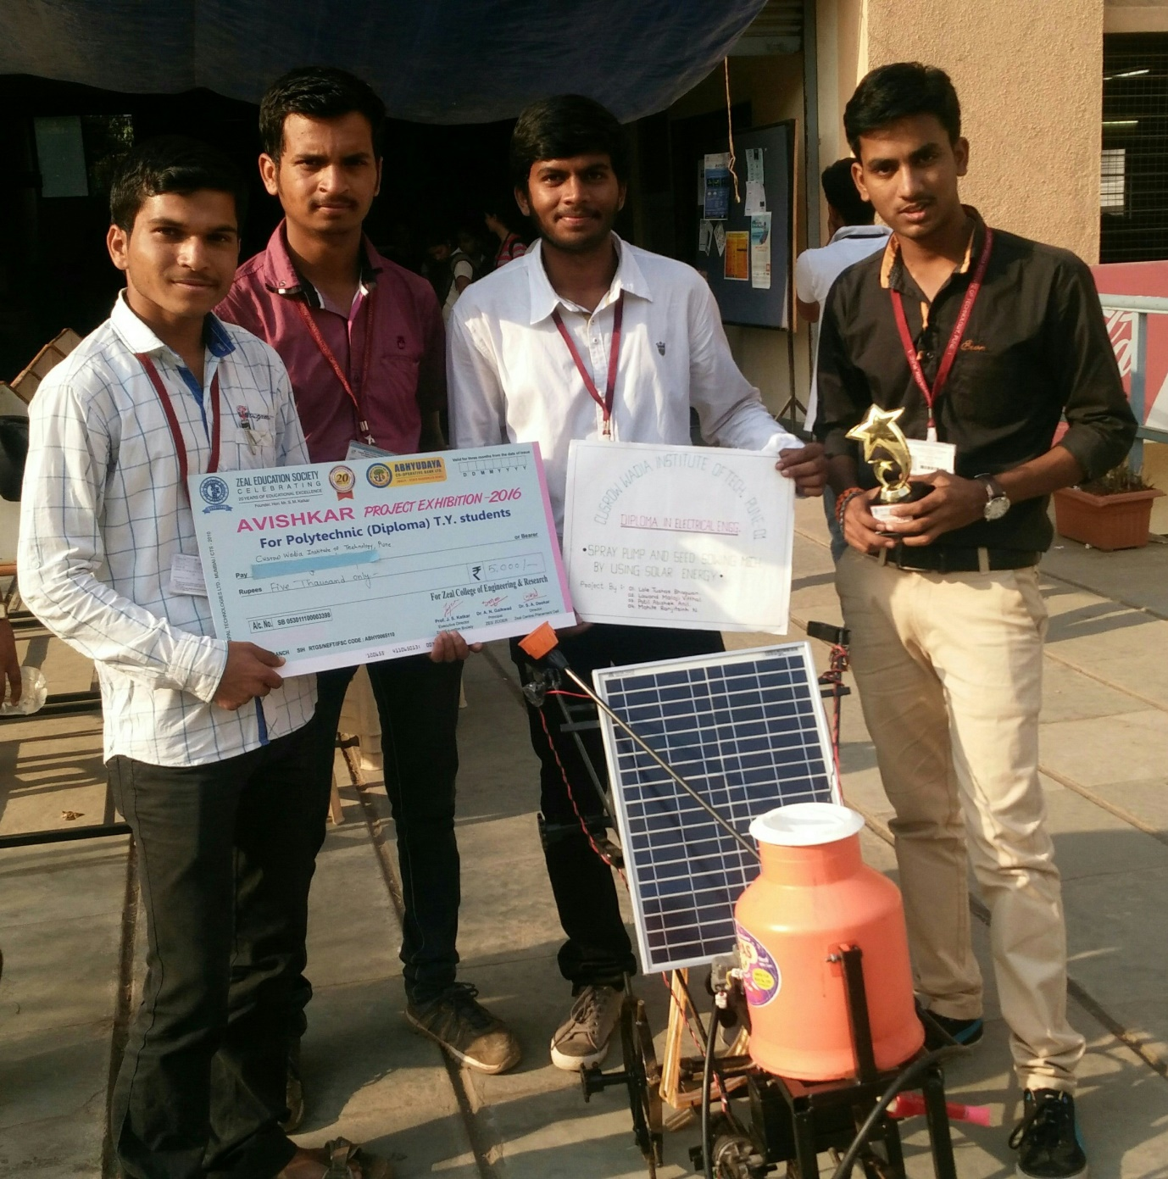

**Index**

|  |  |  |
| --- | --- | --- |
| Chapter No. | Title of the Chapter | Page No. |
| 1 | Introduction  1.1 Problem Statement  1.2 Objectives  1.3 Scope  1.4 Methodology  1.5 Objectives of the project | 1  1  1  1  2 |
| 2 | Construction & Working of Project  2.1 Selection of Sowing and Planting Machine  2.2 Parts used in the project  2.3 Diagram of the project  2.4 Working of the project | 3  3  5  5 |
| 3 | Design of the Project  3.1 Design consideration of the project  3.2 Design of the project | 7  11 |
| 4 | Manufacturing process of the project  4.1 Manufacturing process ( Mechanical)  4.2 Product development process | 17  18 |
| 5 | Benefits and Application of project  5.1 Benefits  5.2 Applications | 23  23 |
| 6 | Conclusion | 24 |
| 7 | Reference | 25 |